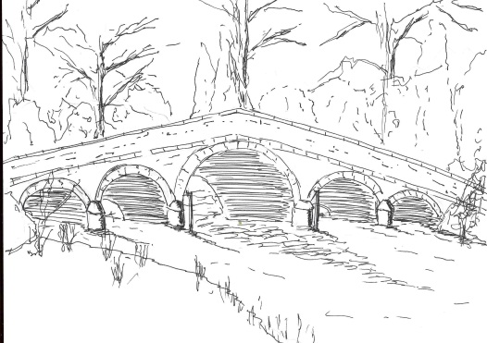 383
Skerne and Wansford Parish Council

Church Cottage, Wansford, Driffield, YO25 8NT
e-mail: jill_pick2001@yahoo.co.uk
tel: 01377 254741
Minutes of a meeting of the Skerne and Wansford Parish Council which took place on Tuesday January 19 2021 remotely via Zoom

- Present: Councillors Lynn Stockwell, Ian Lamble, Mark Padgett, Caroline Harrison, Gill Grassam, Ann Kitching (via WhatsApp) and ERYC ward councillors Jane Evison and Jonathan Owen.

- Apologies: Coun Jack Dobson, Coun Neil Robson.

- Public session: No members of the public present.

- Declarations of interest: None

- Confirmed: the minutes of the meeting on November 17 2021 as a true and correct record, proposed Coun Stockwell, seconded Coun Grassam.

- To dispose of any business remaining from the previous meeting and, if necessary, decide on a course of action:
- Skerne village green: nothing had been heard about the transfer since October. After a long discussion it was decided that a telephone call to Warrendale Farms, to whom the parish council remained grateful, might be appropriate. Coun Bristow would make the initial approach.
- Harmony Energy: nothing had been heard about the contract. It appeared that some work may have started near the sub-station on Wansford Road.
- Skerne bridge – width limit and weight restriction to be imposed with priority signage. A long discussion ensued about this. Members were very concerned for the farmers with land on either side of the bridge and the impact on the centre of Skerne of this proposal when al locally-generated farm traffic would have to use Main Street. It was agreed that the clerk would relay their feelings to the bridge engineer and object to the affiliated planning application (item 7i).
- Road safety issues and posters, harvesting operations: Coun Harrison had discussed this with Nafferton Feoffees Trust who wished to support the scheme as Nafferton village was having similar problems with tractor drivers using mobile telephones and driving at an inappropriate speed in residential areas. The Feoffees planned to try to involve Nafferton CP School with the poster initiative. As any Feoffees-backed scheme would not involve Skerne, Coun Harrison suggested a community fund-raiser when restrictions allowed involving farmers and residents, all of whose interests were represented by the council, which had sympathy will all parties. Coun Owen said a similar problem in Rudston had ended with a farmer co-operating with the council and all his drivers having ID in their cabs enabling villagers to report them direct to their employer. Members decided to discuss this suggestion at a later date and perhaps contact individual farmers to enlist their support.
- Applications for clerk job vacancy: up January 19 two people had expressed an interest in the post. The application deadline was January 31.
- Parish council dinner provisionally booked for April 2. Noted.
- Back Lane drainage – passed onto to area engineer. Coun Kitching said she had called on the ERYC on several occasions about this issue and an engineer, coincidentally, had visited the area at the time of a deluge and seen the extent of the problem. He had indicated that there was money for a drainage scheme and would get back to her when a decision had been made.
- Carr Lane bridge – an engineer has viewed the bridge and is arranging for repairs to take place. Noted.
- Planning:
- To respond to the following planning applications: 20/03991/PLB alterations to create footways to either side of Wansford Bridge, Skerne Road. Applicant: ERYC. Plans to be taken as viewed. Consultation period extended to fit in with parish council meeting. Already discussed in item 6iii.
- To note the following planning decisions: 20/02218/REM – erection of two dwellings and conversion of cart sheds following demolition of farm buildings. Applicant, I Pick & Sons. Approved. Noted.

384
- Finance:
- Bank balances at December 31 2020: Active saver, £1,281.69 (£1.28 interest over the year); Business a/c £4,127.93. Total £5409.62. Noted.
- Precept form accepted. Noted.
- Currys/PC World – invitation to renew insurance on parish council laptop at £66pa. Agreed: no action to be taken.

- Correspondence:
- ERYC – Proposed road safety scheme between Wansford and North Frodingham – previously circulated. Members applauded this scheme which would extend the Wansford 30mph limit and introduce a 50mph limit on stretches of the B1249 between the village and North Frodingham
- ERYC – Carr Lane Bridge. Already noted.
- Conservative Group – devolution discussion re Hull and East Yorkshire. A lengthy discussion ensued. It was greed that the clerk writes to the Chief Executive and the Leader of the Council expressing concern that the public consultation period was only taking place after plans had been drawn up and the public was not to be involved in whether or not they felt an alignment with Hull was appropriate.
- Coun Ian Lamble -resignation of chairman with effect from the May 2021 meeting. Noted.
- SLCC – renewal invitation re clerk’s membership, can be carried over to a new clerk. Resolved: that the clerk renew membership on the understanding that it could be transferred to a new clerk. Proposed Coun Harrison, seconded Coun Grassam.

- Matters requested by councillors:
- State of dyke alongside the Nafferton Beck from the Pleasant Wood bridge to Chapel Lane. The dyke from Pleasant Wood to the Chapel Lane had been cleared by the farmer. However, water was being held up between Carr Lane and Chapel Lane as the dyke had not been maintained for some years. Following the 2007 floods, having made no progress on the issue with the landowner, the parish council had paid for the Mill Croft dyke to be cleaned out although this was actually the riparian owner’s responsibility. Coun Owen suggested getting in touch with the principal engineer regarding enforcement action.

- Highways: A pothole on the B1249 north of Whinhill had been repaired but opened up again almost immediately. Grips on the B1249 were blocked. Agreed: the clerk contact highways regarding these issues. Some work had been done on the village drains and yellow and blue markings had appeared. Agreed: that the clerk ask the principal engineer what these signified. Coun Stockwell reported that she had walked the Driffield Navigation permissive path and remarked on the good work the Beverley Ramblers had made of the path.

- To receive reports from representatives: Coun Harrison said if there were any young people in Wansford going to university in the autumn, applications were soon opening for the Feoffees’ bursary scheme.

- Items for next agenda: None

- Date of next meeting/annual parish meeting. The next parish council meeting would take place on March 16 at 7.30pm. As it was likely to be a remote meeting it was decided to defer the annual parish meeting until May.

