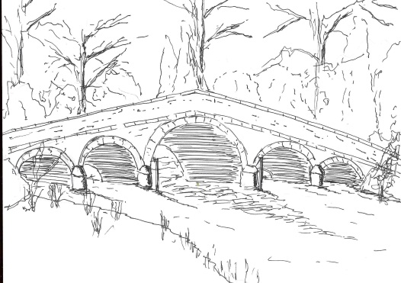
Skerne and Wansford Parish Council

Church Cottage, Wansford, Driffield, YO25 8NT
e-mail: jill_pick2001@yahoo.co.uk
tel: 01377 254741
You are summoned to a meeting of the Skerne and Wansford Parish Council to take place on Tuesday May 18 2021 in Wansford Village Hall immediately following the annual parish meeting which starts at 7.15pm.

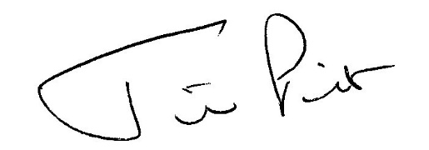

Mrs Jill Pick
Clerk, Skerne and Wansford Parish Council
Church Cottage, Wansford
e-mail: Sandwpclerk@yahoo.co.uk Tel: 01377 254741

May 11 2021

AGENDA

- Present:

- Apologies:

- Declarations of interest:

- To elect a chairman and a vice-chairman. Chairman and vice-chairman to sign acceptance of office forms

- To confirm the minutes of the meeting on March 16 2021 as a true and correct record:

- To dispose of any business remaining from the previous meeting and, if necessary, decide on a course of action:
- Skerne Church/Church Farm path (letter to Church Farm circulated)
- Road safety posters
- Skerne playing field
- Casual vacancy
- Clerk vacancy
- Planning:
- To respond to the following planning applications: 21/01087/PLF and 21/01088/PLF – both for erection of replacement cattle sheds on land north of Spring Farm, Back Lane, Skerne; applicant J H Dixon & Son (e-plans previously circulated, paper location plan included with agendas)

- Finance:
- to consider the council from declaring itself exempt from sending the completed Annual Governance and Accountability Return (AGAR) to the external auditor and, subject to the decision, to return the certificate to the external auditor
- to review the effectiveness of the internal control system
- to resolve to complete and approve the annual governance statement
- to resolve to approve the annual accounting statement
- to accept the statement of variances for the year and the year-end bank reconciliation
- to note that Mr Malcolm Jordan very kindly carried out the internal audit and has indicated that he is willing to do it next year; to consider sending a letter of thanks
- to ratify March payment of £103.20 (inc VAT) to ERYC re salt bin winter maintenance visits 2020-21
- to note that a VAT reclaim of £99.39 for the year April 1 2020 to March 31 2021 has been submitted
- to note that the parish precept of £4,750 has been received
- to note bank balances at April 30: business current account, £7,094.23 and business savings account, £1,281.69, a total of £8,375.92.
- to review membership of ERNLLCA and, if in agreement, to resolve to pay annual subscription of £294.63
- to resolve to pay Wansford Village Hall hire charge of £10 for the 2020-21 year and £11.22 for electricity to the defibrillator for the year.
- to resolve to pay clerk’s expenses of £89.51
- to resolve to pay grant of £275 to Wansford Village Hall, and grants of £275 to St Leonard’s Church PCC and £300 to St Mary’s Church PCC, both in respect of burial ground maintenance

- Administration and training:
- to review financial regulations and standing orders to ascertain if they are working effectively
- to nominate three people to serve on the personnel committee
- to nominate three people to check the books on a meeting-by-meeting basis
- to choose a representative to the Nafferton Feoffees Trust

- Correspondence:
- ERYC: repair works to start on Skerne Bridge on May 28 with closure of road except for cyclists and pedestrians
- ERYC: surface dressing of unclassified road at Rickle Pits scheduled between April 6 and September
- Harmony Energy: CEO Peter Kavanagh has indicated that the parish council should decide whether to accept a one-off payment of £80,000 or ongoing payments of £10,000. (Email circulated).
- Coun Mrs Jacqueline Dobson: Coun Dobson has indicated that she will not accept a nomination for vice-chairman and will be leaving the council before the end of the year.

- Matters requested by councillors:
- Leading sileage through Skerne: Coun Bristow has been in communication with the biogas company, which wishes to work with the village while conducting its lawful business
- Tree trunk on Wansford Lock

- Highways:

- Reports from representatives

- Items for next agenda:

- Date of next meeting:

