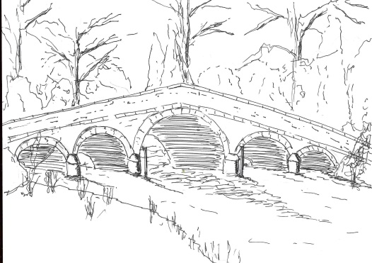
Skerne and Wansford Parish Council

Church Cottage, Wansford, Driffield, YO25 8NT
e-mail: jill_pick2001@yahoo.co.uk
tel: 01377 254741
You are summoned to the annual meeting of Skerne and Wansford parish to take place on Tuesday May 18 2021 in Wansford Village Hall at 7.15pm.

Mrs Jill Pick
Clerk, Skerne and Wansford Parish Council
Church Cottage, Wansford
e-mail: Sandwpclerk@yahoo.co.uk Tel: 01377 254741
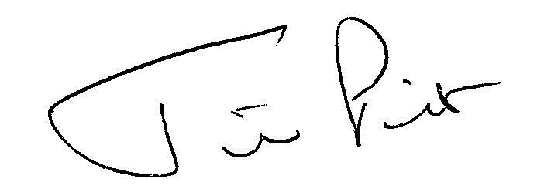

May 11 2021

AGENDA
- Present:
- Apologies:
- Declarations of interest:
- To confirm the minutes of the annual parish meeting held on March 19 2020 as a true and correct record:

- Matters raised by members of the public

- Date of next meeting

MINUTES OF THE 2020 ANNUAL PARISH MEETING

Minutes of the annual meeting of Skerne and Wansford parish meeting which took place on Tuesday March 17 2020 in Wansford Village Hall at 7pm.

Present: Councillors Ian Lamble, Jackie Dobson, Catherine Brennand, Ann Kitching, Neil Robson, Caroline Harrison, Gill Grassam and ERYC ward councillors Jane Evison and Jonathan Owen.

Apologies: Councillors Lynn Stockwell and Mark Padgett

Declarations of interest: None
To confirm the minutes of the annual parish meeting held on March 19 2019 as a true and correct record: Proposed Coun Bristow, seconded Coun Dobson

Matters raised by members of the public: no members of the public present

Date of next meeting: March 16 2021

