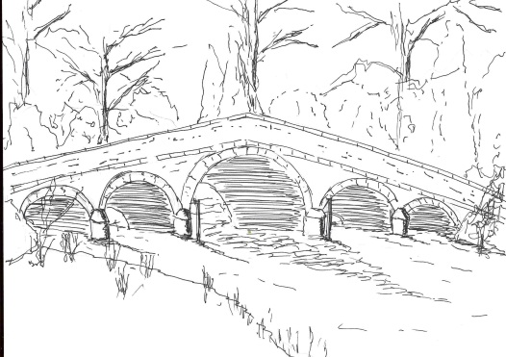

Skerne and Wansford Parish Council
Asset register 2019

Skerne bus shelter
Wansford bus shelter
Seven village seats – five in Wansford, two in Skerne
Two notice boards – one in Wansford, one in Skerne
One picnic table – on Wansford lock
Two petrol water pumps – one at Broadmead House, Skerne, the other at 9 Nafferton Road, Wansford.
Two grit bins
Two pedestrian spreaders
One interpretation board
Two emergency boxes
One telephone kiosk (Nafferton Road, Wansford)
Two defibrillators
Various pots, tubs and planters

Office equipment
One Epson projector
Local Government Administration
HP Pavilion laptop
Epson printer
Computer case
One laminator

Insurance cover
Mowers and equipment 2,234.64
Street furniture 29,818.48
Total 32,053.12

Office equipment insured under policy subject to £250 excess

