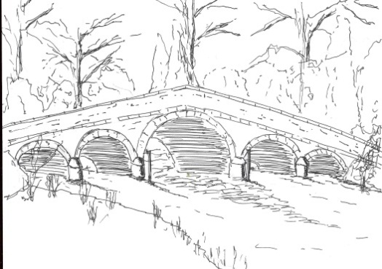276

Skerne and Wansford Parish Council
Minutes of the Skerne and Wansford Parish Council meeting, which took place in Wansford Village Hall on July 17 2012 at 7.15pm.
- Present: Councillors Ian Lamble, Neil Robson, Jackie Dobson, Bryan Hills, Ann Stoney, Marian Terry, Sue Waites and PCSO Chris Webster.

- Apologies: Coun Mark Padgett, ERY councillors Jane Evison and Jonathan Owen.
- Public session: At this point the meeting was suspended for PCSO Chris Webster to give a presentation on policing issues in the villages. He said that the police at Driffield had lost 50 per cent of its workforce and four PCSOs covered 250 square miles. He was aware of speeding issues in Wansford and would ask the traffic police to conduct a campaign in Nafferton Road and near the Trout. He was made aware of similar problems in Skerne and would push for a campaign there. He asked that issues of vandalism be reported and, should these fall into a pattern, the police would monitor the situation at the appropriate time and place. The clerk would send him minutes and agendas of meetings by e-mail to keep him in touch with the villages.

- Declarations of interest: None
- Resolved: to confirm the minutes of the meeting held on May 15 2012 as a true and correct record: Proposed by Coun Dobson, seconded by Coun Hills.

- To dispose of any business remaining from the previous meeting and, if necessary, decide on a course of action:
- Village jubilee committee update. Committee chairman Ian Lamble reported that, after everything had been paid, there was £199 left and a meeting to ask village residents how it should be send and further fundraising was contemplated. Councillors congratulated the committee on organising an excellent day – and weather – and paid tribute to the hard work that had gone into making the celebrations such a success.
- Newsletter – Coun Hills submitted his profile. The next newsletter would be in September, following the parish council meeting. Skerne’s allocation had been short – more needed to be printed.
- Skerne and Wansford Emergency Plan: In progress, the clerk would now contact directly to ask for help.
- Wansford enhancement scheme: Coun Harrison not in attendance. Deferred.
- Wansford noticeboard – the chairman had priced up the materials for two noticeboards and it had come to £700. It was decided that he would try and seek cheaper options and come back to the next meeting.

- Finance
- Noted: Customs and Excise repayment of £422.30 VAT
- Noted: Bank reconciliation statement.
- Noted: salt spreaders have been added to insurance policy at no extra charge, providing a new schedule is not required. Councillors in agreement with this.
- Noted: a grant for £100 has been awarded(and received for the purchase of a second emergency box and contents.

- Administration
- Resolved: that the Code of Conduct, as adopted by the East Riding of Yorkshire Council on April 4 2012 be adopted to take effect as of July 1 2012, subject to review following the receipt of further information

277
from the Monitoring Officer/ERYC in relation to pecuniary or non-pecuniary interests.). Proposed Coun Hills, seconded Coun Stoney.
- To accept completed Register of Interest forms for submission to County Hall by July 28 and posting on the Skerne and Wansford website.
- Resolved: to accept Government appointment of Littlejohn LLP as external auditor. Proposed Coun Hills, seconded Coun Stoney.
- Resolved: To adopt updated Freedom of Information policy.. Proposed Coun Stoney, seconded Coun Dobson.

- Correspondence
- ERYC Conservative Office: re parish cluster meeting on Thursday July 26. Coun Robson would try to go if work commitments permitted.
- National Grid: Carbon capture project consultation. Councillors had concerns about a block valve site in the parish and the overall impact on the SSSI expressed these on a consultation feedback form
- Lissett Community Windfarm Fund: the annual review meeting had been attended by the chairman and vice-chairman, who suggested a parish council grant application for match funding could include an information board for Wansford, village signs for Skerne and perhaps a noticeboard for each village. The clerk to contact Wold Newton Parish Council re their noticeboard supplier.
- St Mary’s Church, Wansford: Noted: letter of thanks re £210church yard maintenance grant
- St Leonard’s Church, Skerne: Noted: e-mail of thanks re £210 church yard maintenance grant

- Matters requested by councillors
- Skerne bridge problems. Coping stone s and subsequently wall stones had disappeared from the five-arched bridge. It was considered that this may have been vandalism. The ERYC had been informed and new coping stones had been ordered by them.

- Highways:
- Work on Skerne potholes had been started, Dave England had said that work near Wansford roundabout would start after the bird nesting season was over.
- There was no indication (a yellow line) that the pothole on the Hutton Road at Skerne was to be included in the repairs. There was also a pothole outsider Leylandii in Skerne. The clerk to report these matters to Dave England. Concerns were expressed about lorries using Back Lane, which was unsuitable for such vehicles.
- Blocked drains in Skerne. Coun Waites had taken pictures. These would be sent to Dave England. The issue of blocked drains to be raised in the newsletter urging residents to report them both to the parish council and the appropriate authorities.

- Other correspondence ERNLLCA newsletters; ERNLLCA agm.
- To receive reports from representatives:

- Driffield Partnership meeting on May 24: the chairman had attended this and would go to a second meeting on July 25 at the Driffield Rugby Club. It was a coming together of various interested agencies to try and and access funding and to speed up work on the navigation. Coun Lamble felt a village representation was important as one idea mooted at the previous meeting had been to close the road between Skerne and Wansford as the cheapest option to deal with the Skerne bridge problem.
- Driffield Navigation, Coun Hills said the DNA had asked that the parish council explore funding opportunities to restore the canal footpath. Some such opportunities were only open to parish councils. The clerk to contact Couns Owen and Evison for assistance in this.
- Nafferton Feoffees: Coun Harrison not present.

- Items for next agenda: Notice boards, information boards.
- Date of next meeting: Tuesday, September 18 at 7.30pm in Wansford Village Hall.
Signed:…………………………………………………………..Date:……………………………………………

