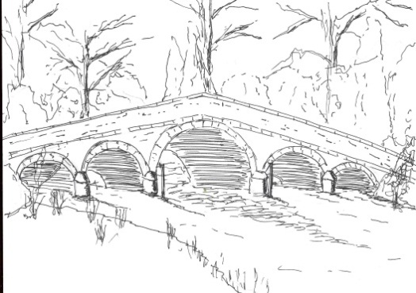

Skerne and Wansford Parish Council
Minutes of a meeting of the Skerne and Wansford Parish Council, which was held in Wansford Village Hall on Tuesday November 18 2014 at 7.30pm.
Present: Councillors Ian Lamble, Neil Robson, Jackie Dobson, Caroline Harrison, Sue Waites, Lynn Stockwell and ERY councillor Jane Evison.

- Apologies: Councillors Cara Boyes, Mark Padgett, who had sent a letter of resignation, and ERY councillor Jonathan Owen. The clerk to contact ERYC with notice of a council vacancy.

- Public session: No members of the public present.
- Declarations of interest: None.
- To confirm the minutes of the meeting held on September 16 2014 as a true and correct record: Proposed Coun Waites, seconded Coun Harrison with the addition of Coun Lamble to the list of apologies.

- ERYC ward councillors: Coun Evison mentioned the work of the ERYC concerning the outbreak of avian influenza at Nafferton in attempting to reassure people of the safety of chicken meat and eggs and inform them about bio-security.

- To dispose of any business remaining from previous meetings and, if necessary, decide on a course of action:
- Cycle track between Nafferton and Wansford. ERYC had replied saying this was not financially possible and recommended use of the national cycle network via Carr Lane. Noted.
- Jubilee funds for Skerne bulb planting scheme. Deferred to September 2015 as bulbs were no longer available.
- Working parties re enhancement scheme. Much work had already been done. Coun Stockwell and her husband would do the planting and organise another working party when more beds had to be constructed. Various people had agreed to care for the planters and others were to be asked. The working party was thanked.
- Weed cutting on Nafferton beck. Councillors felt that spraying the weed on Nafferton beck up and down stream of the Mill Farm weir was not an appropriate alternative and agreed that the clerk write again to the Environment Agency asking it to exert its authority on the landowner to have the beck properly maintained.

- Finance
- The budget was received. Agreed that a precept of £3,100 be considered: proposed by Coun Stockwell, by Coun Waites. This may be subject to change following guidance form the ERYC and Government.
- Received: Bank reconciliation.

- Administration
- Emergency plan – updated. Noted.
- Training
- ERNLLCA conference, Nov 14 2014. Noted.
- Code of Conduct training: Coun Stockwell gave a summary of the course.
- ERYC: Safeguarding adults at risk: Noted.
- SLCC course on Tuesday December 9: Agreed that the clerk could attend and raise a cheque for this.

- Correspondence
- ERYC ward councillors re Humberside Police Review. Noted.
- ERYC: East Riding boundary referendum. Noted.
- Driffield School – re grant for Twilight bus service. The clerk to write declining to grant aid the service..
- ERYC: Polling station consultation. Noted.
- John Hawley: forwarded letter from Yorkshire Water re drainage system. Noted.
- ERYC: Gerry Frisby re surface water drainage: Coun Evison would ask for a plan showing the position of drains and sewers in Wansford with clear information on the designation of each.
- Yorkshire Water: re drainage. Noted.
- ERYC: Rough Sleeper estimate: the clerk to complete
- Yorkshire Water: locating private pumping stations for transfer to YW ownership. Noted.
- ERYC: Local Transport Plan. Noted.
- ERYC: proposed closure/removal of Skerne telephone kiosk. Coun Sue Waites to try to ascertain level of support in Skerne for retention of the kiosk in parish council ownership as a village feature. Agreed that if the feeling was that the kiosk should be kept the clerk to contact ERYC supporting that option. Proposed Coun Waites, seconded Coun Robson.

- Matters requested by councillors
- Information board on the Wansford lock in light of Driffield Navigation’s intention to reinstate the towpath/footpath. The clerk to contact Driffield Navigation with a view to making a joint application to the Lissett Windfarm Fund for funds for both the footpath between Whinhill and Wansford including the provision of an information board at Wansford
- Landline telephone service to village. Agreed that the clerk write to MP Sir Greg Knight outlining the failing landline provision in Wansford and Coun Evison would try to find contacts at BT/Openreach who could be approached regarding this ongoing problem.

- Highways:
- Mrs Catherine Bristow of Skerne, after e-mail consultation with the clerk, had contacted ERYC and made arrangement for a speed assessment in Skerne to take place next harvest, when heavy agricultural machinery would be going through.
- The clerk to write to highways concerning the reflector post at Wansford, chevrons at West End, Skerne, potholes at West End
.
- Other correspondence: ERNLLCA newsletters, East Riding News. Noted.
- To receive reports from representatives: Driffield Navigation, Feoffees. The clerk had been to the Driffield Lock opening.

- Items for next agenda: Chairman’s awards, Wansford Village Hall agreement re electricity for defibrillator

- Date of next meeting; January 20 2015.

