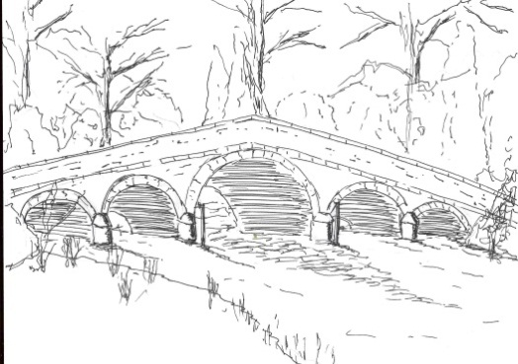 280

Skerne and Wansford Parish Council
Minutes of a meeting of the Skerne and Wansford Parish Council held on Tuesday November 20 2012 in Wansford Village Hall at 7.30pm.
- Present: Councillors Lamble, Robson, Harrison, Terry, Waites, Hills and Dobson
- Apologies: Coun Padgett and ERY councillors Owen and Evison. It was noted that Coun Ann Stoney, who had sent apologies, had since resigned due to re-location.

- Public session: No members of the public present.

- Declarations of pecuniary and non-pecuniary interests: The clerk received written requests for dispensations for councillors to discuss and vote on item 8i (setting(the precept) from all councillors present. These were granted.

- To confirm the minutes of the meeting held on September 17 2012 as a true and correct record: Accepted and signed – proposed by Coun Dobson, seconded by Coun Hills.

- To dispose of any business remaining from the previous meeting and, if necessary, decide on a course of action:

- Wansford enhancement scheme. There had only been verbal feedback from villagers. Coun Harrison asked for a renewed call for suggestions in the forthcoming newsletter and volunteers to form a village committee to put a scheme together. It was hoped that tidying the canal bank would be part of any scheme.
- Proposal to make a grant application for two new notice/information boards. A grant of £168 for grit had been approved b y the local grants fund. The parish council still had in excess of £900 to claim for this fund, which would also fund village noticeboards. The chairman had obtained prices for noticeboards from a Beverley company, indicating that these would cost £926 each. The clerk to apply for the remainder of the community fund, with the balance to be made up from the parish council reserve and fund-raising. Meanwhile prices would be obtained for information boards and a grant application would be submitted to the Lissett Windfarm Fund in early 2013.
- Newsletter: It was agreed to carry on with the newsletter for the time being.
- Planning
- DC/03130/VAT/EASTNN/RL – Variation of condition 10 of permission 11/02342/PLF RE THE Eagle Inn, Main Street, Skerne, for Mr Angus Naylor. Approved. Noted.
DC/03658/VAR/EASTNN/JA – Removal of conditions (restricting to holiday occupancy only) of permission 07/00931/PLF at 1 The Old Chapel, Chapel, Lane, Wansford, for Mr and Mrs M Grassam. Refused. Noted.

- Finance
- To consider the budget and set the precept for 2013-2014. The chairman considered that, if the council was to move forward with helping the two communities an increase of at least £100 would be necessary. After a full discussion Coun Hills proposed that the precept be increased by £150 to £2,800. This was seconded by Coun Dobson. It was noted that the ERYC was still awaiting advice from the Government about whether parish precepts were to be frozen for the forthcoming year. The budget was accepted – proposed by Coun Terry, seconded by Coun Waites.
- Bank reconciliation – noted.
281
- Administration
- Resolved: To adopt the Emergency Plan. Proposed by Coun Hills, seconded by Coun Dobson.
- Resolved: To devolve responsibility for renewing the insurance cover at the best price and deal to chairman and clerk. However, the council was minded to accept a three-year deal from the current providers, Came & Company. Proposed by Coun Hills, seconded by Coun Terry.

- Correspondence
- ERYC: Waterways Strategy 2010-20 Consultation Draft – to be completed by October 19. Noted.
- National Grid – consultation update on carbon capture scheme
- Driffield Canal Partnership – Invitation for a parish council representative to join a working party looking at paths, cycle ways and virtual access along the canal to promote, market or develop through funding opportunities. Cou Hills agreed to attend, as an observer, lunchtime meetings on December 5 and 11 at the Trout Inn. It was noted that Brian Kitt, of the Canal Partnership, had written an article for the newsletter concerning the re-opening of the old towpath.
- ERYC:- Flood Liaison Group agenda (September 28 meeting) and minutes (February 10 meeting). Noted.

- Matters requested by councillors
- Overgrown dykes in the area. The dyke between Wansford and Skerne was full and land was flooded. It was understood that the Environment Agency was making its way round the dykes in the area undertaking maintenance.

- Highways:
- Coun Waites remained concerned about self-sown blackthorn on the Skerne to Wansford road, which was obscuring the view for both motorists and cyclists. These were echoed by Couns Lamble and Dobson. Coun Waites said she would gladly have a site meeting with the engineer to point out the problem. The clerk to write again to the highways department mentioning this and a similar problem on the Skerne to Hutton road near Ricklepits..
- The white lines at the t-junction of Main Street and West End, Skerne, needed renewing as they had been obliterated. The West End sign, outside Well House, Skerne, had been damaged by a lorry and needed renewing.
- Flooding: Coun Harrison had received several reports of highway flooding in Wansford. It was noted that the ERYC had informed the parish council that individual reports of highway flooding as it occurred were more effective than subsequent complaints. It was decided to repeat the Floodline numbers in the forthcoming newsletter.

- Other correspondence East Riding News, The Playing Field, ERNLLCA newsletter and notices of meetings. All available for inspection and noted.

- To receive reports from representatives: Coun Harrison reported that the Nafferton Feoffees charity was pushing ahead with an initiative to help local youngsters undertaking apprenticeships. This to be published in a newsletter when firm details were available. Coun Hills reported that the Navigation Trust was stil debating the re-opening of the old towpath.

- Items for next agenda: Notice/information boards

- Date of next meeting: Tuesday January 15 at 7.30pm in Wansford Village Hall.

