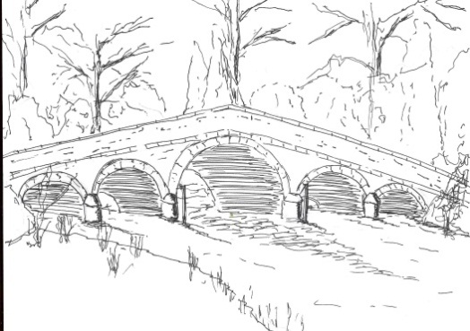 326

Skerne and Wansford Parish Council
Minutes of a meeting of the Skerne and Wansford Parish Council, which was held in the Wansford Village Hall on Tuesday January 19 2016 at 7.30pm.
- Present: Councillors Jackie Dobson, Sue Waites, Gill Grassam, Lynn Stockwell, Ann Kitching, Catherine Bristow, Caroline Harrison, Neil Robson, Ian Lamble (in the chair).

- Apologies: ERYC ward councillors Jane Evison and Jonathan Owen
- Public session: Dani Barge, reporter for the Driffield Times and Post was present.

- Declarations of interest: None
- Resolved: to confirm the minutes of the meeting held on November 17 2015 as a true and correct record, proposed Coun Stockwell, seconded Coun Dobson.

- ERYC ward councillors: to receive updates, information, etc: not present.
- To dispose of any business from the previous meeting and, if necessary, decide on a course of action:
- Skerne bench installation: Coun Waites had discussed the situation with Skerne churchwarden Margaret Brennand and a decision was going to be made on the exact site. Coun Waites had yet to purchase the fixings for the bench.
- Plaque re Feoffee’s input into enhancement scheme: the plaque, purchased on the council’s behalf by Coun Stockwell, was in place. Agreed to reimburse Coun Stockwell for £32.15 including VAT as per minute no 323 7iv
- ERYC Transport Plan: Transport survey and community champion: the completed survey forms had been returned to County Hall. The clerk was the stand-in transport champion pending a permanent appointment.
- Purchase of IT equipment; Resolved: to go ahead with the purchase at the figures previously quoted, with the clerk and chairman to liaise.
- Flooding in Back Lane, Skerne. Coun Kitching had been in contact with the ERYC concerning this ongoing issue of surface water flooding in Back Lane and elsewhere, which was particularly problematical when followed by sub-zero temperatures as affected areas became hazardous. Coun Kitching said there had been a suggestion from ERYC that riparian owners of dykes be contacted re general maintenance as the area was low-lying and, without proper maintenance of the dykes surrounding the village, there was nowhere for the water to go. This matter to be raised in the village newsletter and the clerk to write to ERYC officer Neville Hodgson.

- Finance and administration
- Resolved: to ratify renewal of insurance with Came & Co insurance: on a three-year agreement with an initial payment of £273.75. Proposed Coun Robson, seconded Coun Grassam.
- Resolved: to accept the budget, proposed Coun Stockwell, seconded Coun Harrison. Resolved: to set the precept at £3,350 - £250 more than last year, spreading the cost of the IT equipment over three years. Proposed Coun Dobson, seconded Coun Waites. Agreed: that chairman and clerk make the purchase.
- Resolved: to ratify payment of £239 to Coun Sue Waites for the bench to be sited at Skerne and purchased from Hutton Cranswick Garden Centre. Proposed Coun Bristow, seconded Coun Stockwell.
- Noted: receipt of projector supplied by ERYC Local Grants Fund.

327
- Resolved: to ratify payment of £20 for clerk’s attendance at SLCC training course. Proposed Coun Bristow, seconded Coun Harrison.

- Training
- Clerk’s gave a brief resume of the SLCC course in December.
- Correspondence
- Noted: Cuadrilla - fracking in East Riding (all maps circulated electronically)
- Noted: ERYC - E-planning compliance – 137 of 168 parish councils have used system so far, Skerne and Wansford PC fully using consultee access.
- Noted: ERYC - Chairman’s Awards: nominations by January 31
- Noted: ERYC - Making Time For Winter – leaflets to distribute
- Noted: ERYC: Review of dog control orders. (Order in place in all areas accessible to the public in Skerne and Wansford). Councillors remarked that there was a dog fouling problem in both villages. Coun Stockwell to investigate whether a poop-scoop template could be made, the clerk to investigate where these could be purchased.
- Resolved: to renew clerk’s membership at £65 for the year. Proposed Coun Grassam, seconded Coun Kitching.
- Resolved: the clerk contact Lissett Community Wind Farm Fund with a view to obtaining a grant for 20 padlocks and 20 security chains to distribute on an ongoing basis to the elderly and vulnerable within the two villages.
- Noted: Legal requirement to provide both a pension and holiday pay - personnel committee to action and investigate.
- ERYC: Village Task Force satisfaction survey. Clerk to complete.

- Matters requested by councillors
- Resolved: to consider hosting a Library Theatre production at £245 per performance in conjunction with Wansford Village Hall committee. The clerk to write to the committee expressing an interest in this joint project. Proposed Coun Harrison, seconded Coun Stockwell.

- Highways: Tree in Chapel Lane. Clerk to contact Rob Brown, of ERYC highways to ascertain what action was to be taken. A discussion ensued about the trees in the canal near the disabled car park amid fears that water could potentially be held up. Clerk to contact Driffield Navigation Trust and the Environment Agency to ascertain who was responsible. An informal discussion took pace concerning an unexpected bill for grit refills of the two parish council-owned bins. The members felt that the parish council had been on on-demand refills only and wished this to continue. A proper discussion would be held at the March meeting. Meanwhile the clerk to contact ERYC and reiterate the present position that on-demand refills was the wish of the parish council.

- To receive reports from representatives: Nafferton Feoffees, Wansford Village Hall Committee, Driffield Navigation Trust. None.

- Items for next agenda – spring clean, Queen’s 90th birthday celebrations in June, Local Grants Fund allocation for grit, ERYC salt bin maintenance.

- Date of next meeting: Tuesday March 15, annual parish meeting at 7.15pm immediately followed by parish council meeting.

