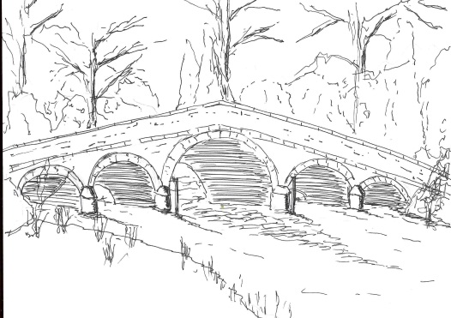
Skerne and Wansford Parish Council

Church Cottage, Wansford, Driffield, YO25 8NT
e-mail: jill_pick2001@yahoo.co.uk
tel: 01377 254741
356
Minutes of a meeting of the Skerne and Wansford Parish Council which took place at 7.30pm Tuesday July 17 2018 in Wansford Village Hall at 7.30pm.

- Present: Councillors Neil Robson, Caroline Harrison, Ann Kitching, Jackie Dobson, Ian Lamble (in the chair) Gill Grassam, Lynn Stockwell, Janet Lester and ER councillor Paul Lisseter.

- Apologies: ER councillors Jane Evison and Jonathan Owen

- New councillor: Mrs Janet Lester submitted Register of Interests. Subsequently received acceptance of office electronically for presentation at the next meeting.

- Public session: The parish council DNT representative Terry Jarvis said there was an intention, in September after the bird nesting season, to cut down trees at Wansford Lock which were causing damage to the lock walls. He and the chairman would arrange a date to view the trees in question.

- Declarations of interest: Coun Dobson re 9i

- Confirmed: the minutes of the meeting on May 22 2018 as a true and correct record: proposed Coun Bristow, seconded Coun Dobson.

- To dispose of any business remaining from the previous meeting and, if necessary, decide on a course of action:
- Village maintenance: Coun Lester said her husband, Clive, would help with the noticeboard and Coun Bristow felt that someone in Skerne could be persuaded to come forward to stain the bus shelter. Coun Lamble could provide most of what was needed. Resolved: that any expenses for teak oil, etc incurred by the volunteers be reimbursed on submission of a VAT receipt, proposed Coun Bristow, seconded Coun Stockwell.
- Purchase of a beacon: shelved for the time being.
- Armistice Day centenary bonfire at Lilleygarth – Mr and Mrs Joe Brierley have kindly offered to put on refreshments but will need an idea of numbers. The clerk to write to Mr and Mrs Brierley accepting their kind offer. The event to be publicised in the September newsletter and a subsequent flyer.

- Planning:
- Noted: 18/00728/PLF and 18/00727 PLF – tandem applications concerning erection of pig finishing livestock buildings, construction of hardstanding and offices at land north of the Beeches, Back Lane, Skerne. Granted with conditions.

- Finance:
- Resolved: to ratify payment of £70 for village hall hire and £24.04 for electricity to the Wansford defibrillator. Proposed Coun Harrison, seconded Coun Kitching.
Resolved: to pay Sue and Billy Waites £24.32 for electricity to Skerne defibrillator. Proposed Coun Bristow, seconded Coun Harrison.
- Resolved: to reimburse Con Robson £9 and Coun Stockwell £13.20 for bedding plants, etc for the lock area and village flower beds at Wansford. Proposed Coun Harrison, seconded Coun Dobson.

- Administration and training:
- Emergency plan – clerk had redone the Emergency Plan in light of new GDPR regulations. However, some responses remain outstanding. Coun Bristow would contact the Skerne people in question.
- Reviewed: Standing Orders (on the website)
- Reviewed: Financial Regulations (on the website)
- Reviewed: internal audit and control policy and procedure (on the website)
- Clerk’s possible attendance at SLCC training day on August 9. Member in agreement.
- Grant applications from various parish council beneficiaries with regards to next year’s budget. Forms to be sent to relevant people.
357
- Insurance regarding the defibrillators. Clerk to contact Came and Co re the acquisition.

- Correspondence:
- Noted: Humberside Police and Crime Commissioner’s office: notice of an impending parish council cluster meeting with the PCC at a date to be notified.
- Yorkshire Ambulance Service re delivery of defibrillator cabinets on July 16 and subsequent installation: Resolved: clerk to contact Walkers, of North Frodingham for an estimate and then put work in train after circulating information to all councillors. Proposed Coun Stockwell, seconded Coun Dobson.
- Noted: Lissett Community Windfarm – deadline for applications extended until July 31

- Highways: Potholes had been repaired in Skerne and on the Skerne to Wansford road.

- Other correspondence: ERNLLCA newsletter, circulated electronically.

- To receive reports from representatives: Driffield Navigation Trust (dealt with in item 4). Nafferton Feoffees - Coun Harrison said there was a Feoffees scheme to help young people just entering employment and asked members to spread the word.

- Items for next agenda: Personnel committee meeting; budget for 2018-19

- Date of next meeting: September 25 2018 to be preceded by Personnel Committee meeting at 7.15pm.

