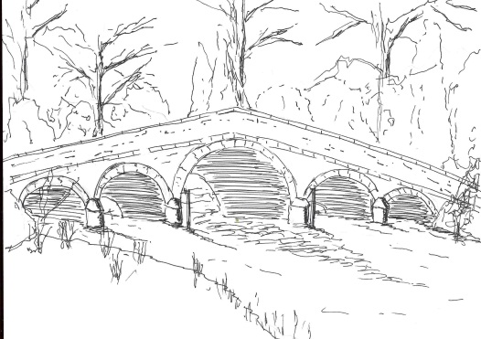
Skerne and Wansford Parish Council

Church Cottage, Wansford, Driffield, YO25 8NT
e-mail: jill_pick2001@yahoo.co.uk
tel: 01377 254741
374
Minutes of a meeting of the Skerne and Wansford Parish Council which took place on Tuesday January 14 2020 in Wansford Village Hall at 7.30pm.

- Present: Councillors Ian Lamble, Neil Robson, Lynn Stockwell, Gill Grassam, Jackie Dobson, Catherine Bristow, Ann Kitching and ERY Jonathan Owen. Also present was Mr Mark Padgett.

- Apologies: Coun Caroline Harrison, ERY Coun Jane Evison

- Public session: Nothing.

- Declarations of interest: None

- To confirm the minutes of the meeting on November 19 2019 as a true and correct record: Proposed Coun Robson, seconded Coun Dobson.

At this point the business moved to item 10v – Co-option of a councillor. Mark Padgett had applied for the casual vacancy. Coun Bristow proposed that Mr Padgett be co-opted and Coun Bristow seconded. Coun Padgett signed the acceptance of office form.

- To dispose of any business remaining from the previous meeting and, if necessary, decide on a course of action:
- Skerne village green update. The draft contract, overage agreement and transfer deed were now with the parish council solicitors - Williamson’s - and the transfer was expected imminently. Once the transfer was complete fencing finances could be explored and Northern Powergrid contacted again re the electricity pole. The working party was still working on the survey to be circulated around both villages.
- Wansford kiosk update: Terry Jarvis had been painting the box and installed some of the new glass.
- Play area inspection training course: Coun Bristow had heard nothing yet.
- Bench in Nafferton Road: Paul and Tracey Moon have this in hand.

- Planning:
- Noted: the following planning decision, 19/03828/PLF – conversion of integral garage to form additional living accommodation with installation of windows to replace garage door at Green Acre Lodge, Skerne. Applicant Mr and Mrs Binnington. Permission granted. Resolved: to ratify no comment response to the application, proposed Coun Bristow, seconded Coun Dobson.

- Finance:
- Resolved: to submit the precept demand for £4,750. Proposed Coun Stockwell, seconded Coun Grassam.
- Resolved: to pay the clerk’s union membership of £103 - £40 for the ALCC and £63 for the SLCC, proposed Coun Bristow, seconded Coun Padgett
- Resolved: to pay Cardiac Science £41.94 (inc VAT) for the replacement electrodes in the Skerne defibrillator and to increase the order to two sets of pads as the Wansford-based defibrillator pads will soon be out of date. Proposed Coun Bristow, seconded Coun Padgett. Agreed: not to stock spare pads given their lifetime.
- Resolved: to ratify payment of £335.50 to Came & Co re insurance cover for 2020, proposed Coun Stockwell, seconded Coun Bristow. Noted: that the clerk was seeking a quote from Zurich to be available with the expiry of the Came & Co long term agreement.

- Administration and training:
- Noted: defibrillator training booked for February 11 from 2pm to 4pm in Wansford Village Hall. Seven people had put their names forward. Coun Grassam asked to be added to the list and Coun Lamble suggested there was someone else who may wish to attend.

375
- Correspondence:
- Wansford Village Hall committee – to elect a parish council representative. Resolved: to elect Coun Dobson, proposed Coun Robson, seconded Coun Bristow.
- Noted: Local Councils Network meeting on January 22 – agenda and October minutes circulated
- Noted: Driffield Navigation Trust re discussions to upgrade the footpath on Driffield Navigation between Whinhill and Wansford; details circulated by email.
- Streetscene satisfaction survey to be returned – circulated. Agreed: that the clerk fill this in. Generally, members were happy with the results of the Streetscene walkabout.
- Already dealt with: Co-option of a councillor: Mark Padgett, of Skerne, has put himself forward to fill the vacancy.
At this point Coun Stockwell said she had sourced a replacement picnic bench for Wansford Lock – the purchase of which was agreed at the November meeting. This was £595 plus VAT and would be purchased with the ring-fenced funds granted to the council by Driffield Canal Partnership for use at Wansford Lock. It would be bought in February so that Jim Stockwell, who would be installing it could work out what fixings were need it in preparation for the spring installation. Resolved: that the purchase be made, proposed Coun Kitching, seconded Coun Dobson
- Matters requested by councillors and members of the public:
- To consider changing the position of the light sensor for the Skerne defibrillator as the light is now almost constantly on. Resolved: that the clerk request that Walkers, of North Frodingham, move the sensor to a spot out in the open, proposed Coun Bristow, seconded Coun Stockwell
- Pie and pea supper. A member of the public had requested another community night. Agreed: that the clerk ask Keith Robinson if he was willing to do this on Friday April 24, with, as last year, an earlier start for people with families.

- Highways: Coun Kitching pointed out that Back Lane continued to flood despite regular gully cleaning. Coun Owen suggested that the clerk write to himself and Coun Evison requesting that the gully system in Back Lane be connected to the Skerne drainage system. Agreed.

- Other correspondence: None

- To receive reports from representatives: Coun Harrison not present; the Feoffees meeting coincided with the PC meeting.

- Items for next agenda: Skerne village green, flooding in Back Lane

- Date of next meeting: Tuesday March 17 at 7.30pm to be preceded by the annual parish meeting to take place at 7.15pm.

