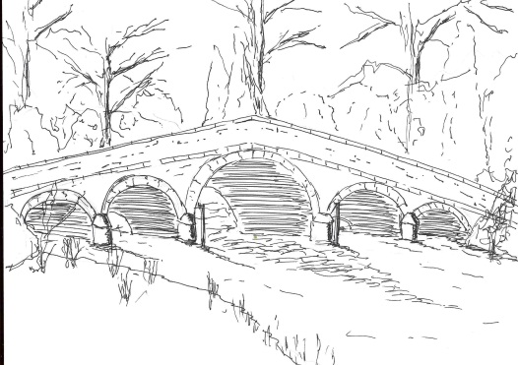
Skerne and Wansford Parish Council

Church Cottage, Wansford, Driffield, YO25 8NT
e-mail: jill_pick2001@yahoo.co.uk
tel: 01377 254741
364
Minutes of a meeting of the Skerne and Wansford Parish Council which took place on Tuesday March 19 2019 in Wansford Village Hall at 7.30pm.

- Present: Couns Catherine Bristow, Ann Kitching, Jackie Dobson, Ian Lamble, Caroline Harrison, Neil Robson, Gill Grassam, Lynn Stockwell and ERY councillors Jane Evison and Jonathan Owen.

- Apologies: None

- Public session: No members of the public present.

- Declarations of interest: None

- Confirmed the minutes of the meeting on January 15 2019 as a true and correct record: Proposed Coun Bristow, seconded Coun Kitching.

- To dispose of any business remaining from the previous meeting and, if necessary, decide on a course of action:
- Resolved: to purchase varnish for newly-acquired bench for Nafferton Road, which was purchased for £224.10 (inc discount). Proposed Coun Dobson, seconded Coun Grassam. This would be applied before putting the bench in place.
- Spotbox supplied by Humberside Police: PCSO Chris Webster had indicated he would soon be using this in Skerne,
- Pie and pea supper: to take place on April 26 at the Trout Inn.
- Resolved: to purchase more postcards regarding dog fouling in both villages: proposed Coun Grassam, seconded Coun Kitching.
- Resolved: to purchase paint for Wansford kiosk – initial scheme of replacing glass and using box as an information centre met with support.

- Planning:
- To respond to the following planning applications: 19/00679 – internal alterations to allow for installation of a shower unit and installation of a bath at Eagle House, Main Street, Skerne. Applicant: Mrs Caroline Naylor. No comment.
- Noted: the outcome of the following planning appeal: 18/00057 – extension to living accommodation and erection of double garage at High Trees, Skerne. Applicant: Mr and Mrs McLoughlin. Appeal dismissed.

- Finance:
- Resolved: to ratify payment of £15 re clerk’s SLCC training course. Proposed Lynn Stockwell, seconded Jackie Dobson.
- Resolved: to ratify payment of £283 o Inland Revenue and Customs – clerk’s tax liability for the 2018-19. Proposed Coun Bristow, seconded Coun Stockwell.
- Resolved: to pay clerk’s net annual salary of £1,132 for year 2018-19. Proposed Coun Grassam, seconded Coun Kitching.
- Received: bank reconciliation for month ending February 28 2019

- Administration and training:
- Clerk’s training day on February 27 at Beverley: forthcoming election, death of sovereign, code of conduct. Agreed: that when the sovereign died, the parish chairman/vice-chairman would make the proclamation at the day and time decreed.
- Reviewed: membership of ERNLLCA – members thought membership was worthwhile. Resolved: to pay subscription for 2019-20 when the invoice came. Proposed Coun Bristow, seconded Coun Grassam.

365
- Correspondence:
- Ian Pick Associates on behalf of Warrendale Farms: offer of an area of land for a community space/playing field in Skerne. Resolved: to accept the land with a view as to how it could be developed as an amenity area in the future. Proposed Coun Kitching, seconded Coun Dobson.
- Noted: Local Government Elections on May 2 – information and nomination forms circulated
- ERYC: Village taskforce walkabout – identify areas that need attention: Coun Stockwell and Coun Kitching would attend the walkabout.
- Resolved: to collaborate with the Wansford Village Hall committee regarding the production of the Library Theatre’s production of My Brilliant Divorce at the hall on September 26. Proposed Coun Stockwell, seconded Coun Grassam.
- Noted: Town and Parish Council Communication Review Panel.

- Matters requested by councillors/other items:
- Spring clean of the village(s). Wansford’s clean up would take place from 10am on Saturday April 27 meeting at the bus shelter. Skerne’s would take place on Saturday May 11, starting at 10am meeting at the bus shelter.
- Skerne noticeboard: Coun Bristow would try and find someone in Skerne to varnish the noticeboard.

- Highways: A resident had sent a list of potholes – clerk to communicate with highways.

- Other correspondence: None

- To receive reports from representatives: None

- Items for next agenda: footpath in Skerne, mirror at Wansford roundabout.

- Date of next meeting: May 21 at 7.30pm

