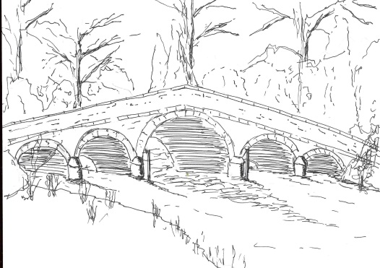
Skerne and Wansford Parish Council

Church Cottage, Wansford, Driffield, YO25 8NT
e-mail: jill_pick2001@yahoo.co.uk
tel: 01377 254741
Minutes of the Skerne and Wansford annual parish meeting which took place on Tuesday March 19 2019 in Wansford Village Hall at 7pm.

- Present: Couns Jackie Dobson, Catherine Bristow, Ian Lamble, Ann Kitching, Caroline Harrison, Neil Robson, Gill Grassam, Lynn Stockwell and ERYC councillors Jane Evison and Jonathan Owen.

- Apologies: None
- Declarations of interest: None
- Confirmed the minutes of the meeting held on March 20 2018 as a true and correct record: Proposed Coun Bristow, seconded Coun Kitching.

- Correspondence: Ian Pick Associates on behalf of Warrendale Farms. Offer of a parcel of land for a community open space/playing field in Skerne (see plan).

- To ascertain active support in Skerne for the above project: Coun Bristow said there was enthusiasm for the project in Skerne.
- Matters raised by members of the public: No members of the public present
- Date of next meeting: March 17 2020

