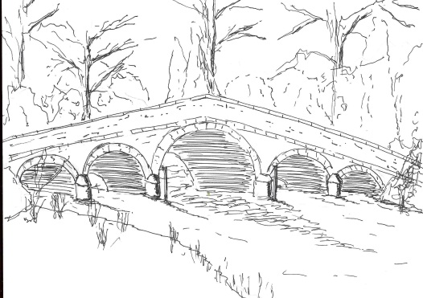
Skerne and Wansford Parish Council

Church Cottage, Wansford, Driffield, YO25 8NT
e-mail: jill_pick2001@yahoo.co.uk
tel: 01377 254741
352
Minutes of a meeting of the Skerne and Wansford Parish Council which took place on Tuesday March 20 2018 in Wansford Village Hall at 7.30pm.

- Present: Couns Ian Lamble, Caroline Harrison, Catherine Bristow, Ann Kitching, Gill Grassam, Neil Robson, Lynn Stockwell and ERY councillors Jane Evison and Jonathan Owen.

- Apologies: Couns Jackie Dobson and Sue Waites

- Public session: No members of the public present

- Declarations of interest: None

- To confirm the minutes of the meeting on January 16 as a true and correct record: Proposed Coun Grassam, seconded Coun Kitching.

- To dispose of any business remaining from the previous meeting and, if necessary, decide on a course of action:
- Noted: ERYC has agreed to consider request for the parish council to take the land at the rear of the old folks’ bungalows as a community space as when they become vacant.
- Noted: Wansford kiosk: when the kiosk is decommissioned, BT will be in touch.
- Items for maintenance: benches, etc. Chairman had looked into cost of varnish, oil, etc. Agreed: that he go ahead and purchase the necessary items. Proposed Coun Grassam, seconded Coun Harrison.
- Border on bus shelter flower beds. Resolved: to reimburse Coun Stockwell £52.02 for paving. Proposed Coun Kitching, seconded Coun Harrison.

- Planning:
- Ratified: no comment response to planning application 17/04280/PLF re external and internal alterations to agricultural outbuildings to use as two holiday cottages following removal of existing agricultural shed at The Beeches, Skerne. Applicant: Mr A Dixon.

- Finance:
- Resolved: to reimburse the clerk £81.85 including VAT for pack of cartridges. Proposed Coun Harrison and seconded Coun Bristow.
- Resolved: to pay clerk’s net salary of £1,100 and to ratify payment of clerk’s tax liability of £275 to Inland Revenue. Proposed Coun Lynn Stockwell, seconded Coun Bristow.
- Received: bank reconciliation for month ended February 28 2018

- Administration and training:
- Data protection course: Ramifications for council and councillors of new Data Protection legislation to be enacted in May. This was discussed. A decision recording appointment of a Data Protection Officer was deferred pending the outcome of ERNLLCA investigations on this subject.
- Reviewed: membership of ERNLLCA with a view to subscribing for the 2018-19 year.
- Resolved: to pay the ERNLLCA subscription when it falls due, should it be the wish of the meeting to continue membership. Proposed Coun Bristow, seconded Coun Kitching.
- Noted: that usernames, passwords and references where applicable for Easily.co.uk (website domain name owners); ERYC consultee planning access; Yahoo e-mail account, PAYE website, parish council website and Microsoft Windows, have been passed to the chairman’s safe keeping in a secure envelope.

- Correspondence:
- Noted: ERY Clinical Commissioning Group: Closure of Minor Injuries Unit in Driffield – posters displayed in both villages. Clerk to precis this in newsletter.
- Noted: Neighbourhood Watch – breaches of the code of ethics: circulated electronically

353
- Yorkshire Ambulance Service: request for the parish council to take on ownership, maintenance responsibilities and associated costs for the defibrillators in both villages. A full discussion ensued and, following a show of hands, councillors resolved to accept ownership of the two defibrillators. Proposed Coun Bristow, seconded Coun Grassam.

- Matters requested by councillors/members of the public:
- Village clean-up day in Wansford: This was scheduled for Saturday April 28, starting at 10am at the bus shelter.
- Situation regarding grit in both villages following recent cold spell. Supplies had been severely depleted in Wansford during the February cold spell.

- Highways: Nil.

- Other correspondence: Nil

- To receive reports from representatives: Nil

- Items for next agenda: Following representations, it was agreed to invite a potential owner of Church Farm, Skerne, to the May meeting for an exchange of information regarding his plans for farming the site, which is to be the subject of a forthcoming planning application.

- Date of next meeting: May 15 2018.

