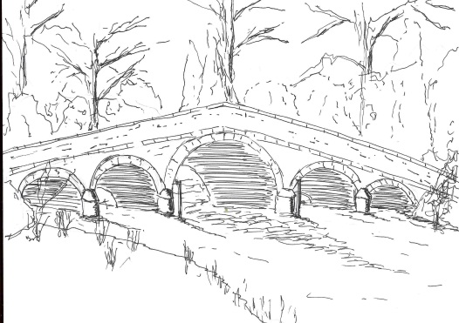
Skerne and Wansford Parish Council

Church Cottage, Wansford, Driffield, YO25 8NT
e-mail: jill_pick2001@yahoo.co.uk
tel: 01377 254741
360
Minutes of a meeting of the Skerne and Wansford Parish Council which place on Tuesday November 20 2018 in Wansford Village Hall at 7.30pm.

- Present: Councillors Ian Lamble (in the chair), Neil Robson, Caroline Harrison, Ann Kitching, Catherine Bristow, Janet Lester, Lynn Stockwell and ERY Councillor Paul Lisseter

- Apologies: Councillors Jackie Dobson and Gill Grassam. ERY councillors Jane Evison and Jonathan Owen.

- Public session: No members of the public present. PCSO Chris Webster in attendance.

- Declarations of interest: None

- Resolved: to confirm the minutes of the meeting on September 25 as a true and correct record: proosed Coun Stockwell, seconded Coun Bristow

- To dispose of any business remaining from the previous meeting and, if necessary, decide on a course of action:
- Emergency plan update – deferred until the next meeting
- Millennium bench in Nafferton Road, Wansford: deferred until the next meeting when local garden centres may be used.
- Noted: purchase of laminator at £44.98 (inc £7.50 VAT) for it and pack of 100 pouches and reimbursement of clerk.
- Beacon bonfire at Lilleygarth Farm, Skerne: this had been excellent event, mainly due to the hard work of Joe and Julie Brierley, their friends and neighbours and the input of Toby Bates. Letters of thanks to be sent.

- Planning:
- Noted the following planning decisions: 18/02753/OUT, conversion of existing cart shed to dwelling and erection of six dwellings following demolition of existing farm buildings at Manor Farm, Wansford. Applicant: I Pick & Sons. Refused. 17/04280/PLF, external alterations to agricultural outbuildings to allow use as two holiday cottages following removal of existing agricultural shed. Applicant, Mr A Dixon. Granted with conditions.

- Finance:
- Noted: VAT refund of £117.58. It is now submitted on line. To note that chairman has been handed updated password list, including Government Gateway ID for VAT claims and unique VAT reference number.
- Resolved: to ratify expenditure of £30 for printing Armistice bonfire flyers for both villages, initially discussed with chairman. Proposed Coun Bristow, seconded Coun Harrison.
- Resolved: to reimburse clerk for above expenditure and £23.99 for a black ink cartridge – total £53.99. Proposed Coun Harrison, seconded Coun Stockwell.
- Accepted: the proposed budget expenditure (circulated electronically) with a view to setting the precept for 2019-20. Resolved: to set the precept at £4,000. Proposed by Coun Lamble, seconded by Coun Harrison.

- Correspondence:
- Noted: ERYC – anti social behaviour statistics, circulated electronically. There had been incidents in Skerne which had been reported. At this point PCSO Chris Webster members how Humberside Police had attended incidents of poaching in Skerne, and had obtained a Spotbox – a speed detecting decide that could be used in villages on request.
- ERYC: Rough sleepers estimate: no rough sleepers in the parish.
- Driffield School: twilight bus service: no action to be taken.

361

- Deferred until next meeting: BT telephones: Parish Council has now taken ownership of the Wansford telephone kiosk
- Noted: Healthwatch – invitation to stakeholder forum.

- Matters requested by councillors:
- New street lighting in Wansford. A resident’s observations concerning the alignment of these was noted.
- Overgrown hedge between Mill Croft and Chapel Lane, Wansford: this had been reported and DERYV had indicate that it would be attend to shortly.

- Highways: The clerk was asked to contact the ERYC highways concerning the ongoing state of the Wansford roundabout, signs on which had been damaged at various times, mainly during the harvest period. Additionally, the 30mph sign on the north side of Skerne Road near Skerne bridge was obscured by overgrown hedges.

- Other correspondence: None

- To receive reports from representatives: None

- Items for next agenda: Spotbox at Skerne, Wansford kiosk, pie and pea night at the Trout, new bench in Nafferton Road, emergency plan

- Date of next meeting: January 15 2019

