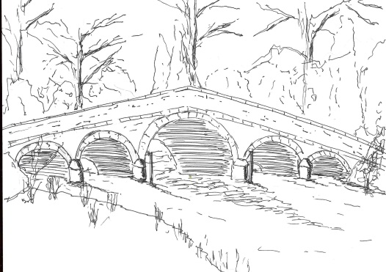
Skerne and Wansford Parish Council

Church Cottage, Wansford, Driffield, YO25 8NT
e-mail: jill_pick2001@yahoo.co.uk
tel: 01377 254741
348
Minutes of a meeting of the Skerne and Wansford Parish Council which took place on Tuesday November 21 2017 in Wansford Village Hall at 7.30pm.

- Present: Councillors Catherine Bristow, Sue Waites, Ann Kitching, Lynn Stockwell, Neil Robson and Jackie Dobson (in the chair), ERY Councillors Jane Evison and Jonathan Owen.

- Apologies: Councillors Caroline Harrison, Gill Grassam and Ian Lamble

- Public session: No members of the public present except PCSO Chris Webster.

- Declarations of interest: None

- Confirmed the minutes of the meeting on September 19 as a true and correct record: Proposed Coun Stockwell, seconded Coun Bristow.

- To dispose of any business remaining from the previous meeting and, if necessary, decide on a course of action:
- Noted: moving the speed limit sign in Skerne was out of the question: reply from ERYC
- Agreed: that co-operation with the church regarding this issue would be the best way forward. Ideally a central site for the bonfire would be most suitable but anything would be welcome.
- Sports field in Skerne. Coun Bristow had not yet contacted JSR Farms again but the site was still for sale.
- Noted: Pie and pea supper at the Trout on December 1
- Resolved: the clerk purchase of ‘clean up after your dog’ flyers at £10 for 250 from dog warden
- Resolved: to pursue the question of ownership of the land with the Land Registry at a cost of £30 after ERYC replied to say that they did not own it.
- Noted: both Skerne and Wansford post-boxes had been painted.
- Agreed: to defer signing the BT contract adopting the Nafferton Road kiosk and reconsult with the parties who expressed an interest in maintaining it to see, one year later, if they were still willing.
- Noted: advice on siting of second litter bin at Wansford lock awaited.
- Noted: ERYC Highways had indicated that a mirror at Wansford roundabout was not a possibility: siting mirrors was not ERYC policy.
- Speeding vehicles on B1279 and in Skerne. PCSO Webster said most villages had a similar problem. The Humberside Police had a speed board they could use intermittently within villages for an hour or so at a stretch and he would put this in motion. Agreed that clerk should write to ERYC Highways asking if there was any appropriate signage at the Driffield entrance to the roundabout warning people of vehicles emerging from the left.
- Planning:

- Noted: 17/02692/PLF, full planning permission for erection of timber stables, store, workshop building and construction of a ménage on land south of Lilleygarth Farm, Applicant: Mr Anthony J Brierley. Approved.
- Noted: 7/02662/PLF, full planning permission for erection of single storey extension to side, pergola to rear, porch to front and detached garage at front, following removal of summer house. The Pinfold Main Street Skerne. Applicant: Mr & Mrs Scholes. Approved.

- Finance:
- To provisionally set a budget for the forthcoming year for amendment/ratification in January or submission before depending on ERYC timetable. A provisional figure of £4,500 was agreed upon. Proposed Coun Stockwell, seconded Coun Robson.
- Noted: receipt of £23.18 from Wansford Village Hall committee re Happy Jack production profit share.

349
- Noted: bank balances as at October 31 2017: community account: £4,839.90; business saver account (0% interest) £473.44; total £5,313.34

- Administration and training:
- Code of Conduct training October 30 at Driffield had been worthwhile.
- Resolved: to approve clerk’s attendance at SLCC training course on Monday December 11 at a cost of £10. Proposed Coun Bristow, seconded Coun Kitching
- Resolved: to approve clerk’s membership of SLCC for the forthcoming year and pay the subscription, possibly in region of £100. Proposed Coun Bristow, seconded Coun Stockwell.
- Resolved: that the clerk can renew the parish council insurance cover when the payment becomes due. Proposed Coun Bristow, seconded Coun Robson.

- Correspondence:
- Noted: ERYC: rough sleeper estimate – morning of November 22. Agreed: there were no rough sleepers within the parish.
- Neighbourhood Watch newsletter (circulated electronically).
- ERNLLCA newsletter (circulated electronically).
- Wansford Village Hall committee invitation to appoint a parish council representative. Agreed: to re-appoint Coun Dobson, proposed Coun Stockwell, seconded Coun Robson.

- Highways: There was a pothole outside Rowan on Nafferton Road, Wansford, Following the accident at the bend near West End Farm, Skerne, it was agreed that the clerk write to EYV Highways asking for something to be done about the standing water there.

- Other correspondence
- Noted: report re Driffield Navigation Trust permissive path by ERYC engineer (definitive map). The engineer’s conclusions were similar to the parish councils’ that the section of path presented a danger to users from road and canal.

- To receive reports from representatives: None.

- Items for next agenda: BT kiosk, border on bus shelter flower beds, beacon, budget.

- Date of next meeting: Tuesday January 16 2018 at 7.30pm in Wansford Village Hall.

