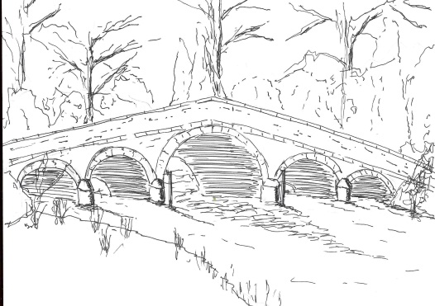 379
Skerne and Wansford Parish Council

Church Cottage, Wansford, Driffield, YO25 8NT
e-mail: jill_pick2001@yahoo.co.uk
tel: 01377 254741
Minutes of a meeting of the Skerne and Wansford Parish Council which took place on Tuesday September 15 2020 in Wansford Village Hall at 7.30pm.

- Present: Councillors Ian Lamble (in the chair), Caroline Harrison, Jackie Dobson, Neil Robson, Catherine Bristow, Mark Padgett, Ann Kitching, Gill Grassam, ERY councillor Jane Evison.

- Apologies: None

- Public session: At this point the meeting was suspended for Harmony Energy CEO Peter Kavanagh to exchange information regarding a possible legally-binding financial planning gain for the parish subject to his company gaining permission for a solar farm between the two villages. Mr Kavanagh told councillors that the sum would be £10,000 a year for community projects within the parish and run for the lifetime of the solar farm, which was expected to be at least 20 years.

- Declarations of interest: Couns Bristow and Dobson declared an interest in item 8vi. The clerk said that she also had an interest in this item.

- Resolved: to confirm the minutes of the meeting by Zoom on July 14 as a true and correct record. Proposed Coun Stockwell, seconded Coun Bristow.

- To dispose of any business remaining from the previous meeting and, if necessary, decide on a course of action:
- Noted: that the external auditor has accepted the parish council’s exempt status, a letter of thanks had been sent to internal auditor Malcolm Jordan and Coun Harrison had supplied a bottle of wine.
- 0 blocked gullies near The Gatehouse and The Haven had been reported to ERYC
- Skerne village green: the legal transfer of the land was still ongoing.
- Harmony Energy planning gain: dealt with

- Planning:
- To respond to the following planning applications: 20/01982/STPLF – installation and operation of a solar farm and associated infrastructure at Back Lane, Skerne. Applicant Harmony Energy. To ratify ‘no objection in principle’ comment to this application made by clerk, in consultation with chairman, under devolved powers. 20/02730/VAR – removal of agricultural occupancy planning condition for Manor Farm: to ratify ‘no comment’ response to this following circulation of the application to members. Responses to both applications were ratified – proposed Coun Stockwell, seconded Coun Bristow.

- Finance:
- Latest bank statement was available to view. Balances at July 31 2020 were: business current account, £4,628.18 and community account, £1,280.41.
- Resolved: to ratify payment of clerk’s expenses of £108.75. Proposed Coun Padgett and Coun Dobson.
- Resolved: to pay £12.21 to Mr and Mrs W E Waites for electricity to Skerne defibrillator for year to mid-July 2020. Proposed Coun Kitching, seconded Coun Padgett.
- Resolved: to increase clerk’s salary for 2021-22 by 2.5 per cent, in line with public sector pay awards, as discussed at the personnel committee. Proposed Coun Harrison, seconded Coun Padgett.
- Agreed: To devolve responsibility to chairman and clerk re purchasing insurance cover from January 2021 onwards.
- Resolved: To set village hall and churchyard grants for 2021-2022 to the sums the organisations had requested ie Wansford Village Hall and Skerne Church, £275; Wansford Church, £300. Proposed Coun Kitching, seconded Coun Grassam.
- Noted: that the Information Commissioner has renewed the parish council registration at a cost of £35

- Correspondence:
- Noted: ERYC: new model code of conduct being reviewed
- Noted: ERYC: Anti-social behaviour statistics

380
- Matters requested by councillors/members of the public:
- Fly-tipping in Nafferton Road. Coun Harrison volunteered to talk to the person responsible. Should the rubbish not be removed within two weeks of the discussion, the clerk would contact the ERYC.
- Weight restriction on Skerne Road: the possibility of requesting this was discussed. It was agreed initially to produce a newsletter article expressing sympathy with farmers who have to put food on our tables but also use ever bigger machinery unsuitable for the roads on which they were travelling. The article should ask drivers of heavy machinery to drive responsibly.
- Skerne bridge; it appeared that it would be between seven months and a year that the bridge would be out of action.

- Highways: Large agricultural machinery was eroding banks both on the canal side of the B1248 between Wansford and Driffield and also on verges within both villages, causing soil to infiltrate the gullies and localised flooding. Once again, the hedge outside Mill Croft was causing a problem which had again been reported to ERYC. Not only was it dangerous for pedestrians having to walk on the narrow bit of road it was obscuring the light.

- To receive reports from representatives: None

- Items for next agenda: Joe Neal from the Ramblers Association had written after the agenda had gone out requesting financial help for the Beverley Ramblers’ project to upgrade the canal side footpath between Whinhill and Wansford.

- Date of next meeting: Tuesday November 17 at 7.30pm either by Zoom or in the Wansford Village Hall, depending on the Coronavirus situation.

