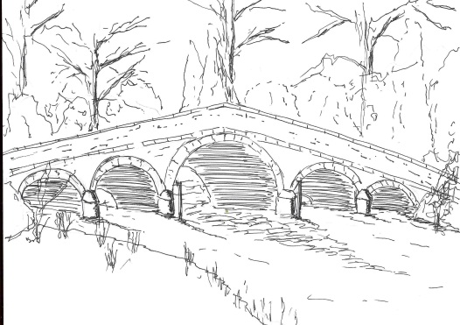
Skerne and Wansford Parish Council

Church Cottage, Wansford, Driffield, YO25 8NT
e-mail: jill_pick2001@yahoo.co.uk
tel: 01377 254741
334
Minutes of a meeting of the Skerne and Wansford Parish Council which took place on Tuesday September 20 in Wansford Village Hall at 7.30pm.

- Present: Councillors Lynn Stockwell, Jackie Dobson, Sue Waites, Ann Kitching, Ian Lamble, Neil Robson, Caroline Harrison and East Riding ward councillors Jane Evison and Jonathan Owen.

- Apologies: Councillors Gill Grassam and Catherine Bristow.

- Public session: PCSO Chris Webster present.

- Declarations of interest: None.

- To confirm the minutes of the meeting on July 19 as a true and correct record: Proposed Coun Dobson, seconded Coun Stockwell.

- To receive updates/information from ward councillors: Item 7ii: A site meeting was suggested at Skerne to discuss the problem and so that all could better understand the situation. This would be arranged at a time to suit Skerne councillors. Item 10iv: The perils of pulling out onto the B1249 and turning left to Driffield were discussed at length. The prospect of a mirror, cutting back the Haven hedge and returning to a t-junction as members recounted near misses when pulling out onto the roundabout with no line of sight to the left. The ward councillors said various road surfaces to slow traffic down could be applied. PCSO Webster said as there had been no accidents in that immediate locality it was not considered dangerous. It was decided to write to Rob Brown, ERYC highways engineer, and request a site meeting. At this point the ward councillors left the meeting. Item 10v: PCSO Webster said to contact the dog warden or, if members were aware of the culprits, he would visit them. PCSO Webster then left the meeting.

- To dispose of any business remaining from the previous meeting and, if necessary, decide on a course of action:
- Noted: Tour de Yorkshire – replies from project manager Bob Brayshaw and ERYC.
- Skerne drains – reply from Rob Brown. Dealt with.
- library theatre touring company event – numbers attending, etc. All the money had not yet been received but it appeared that there would be quite a lot of people attending.
- Noted: Transparency funding grant: to note that grant funding of £652.49 has been paid into the PC account by ERNLLCA
- Camera to film offending dog owners. Since the yellow signs had been painted on the footpaths the problem had diminished. Matter deferred.

- Finance:
- Resolved: to reimburse clerk £26.98 - £17.99 for a black cartridge and £8.99 for a ream of paper. Proposed Coun Waites, seconded Coun Kitching.
- Noted: Annual return – to note that no issues have been identified and no payment has been charged
- Noted: recommendation from Personnel Committee re clerk’s salary 2017-2018 with a view to compiling a budget to put before the November meeting.
- Received: bank reconciliation to August 31 and note current balance
- Noted: that the parish council has registered with the Information Commissioner and the first direct debit of £35 for the current year has been taken from the account
- Noted: that Wansford organisations are eligible to apply for some of the funding from the dispersal of the Nafferton Millennium Bus funds

- Correspondence:
- Noted: Broadband – update re upgrade to the service. The complete transcript of the EYRC reply was on the parish website.

335
- Noted: ERYC: new money for security equipment. One villager had already taken advantage of this and it was to be published in the newsletter.
- Humberside Police: Neighbourhood Networks. Deferred until after the next newsletter.

- Matters requested by councillors:
- Painting of Skerne bridge. Clerk to write to the ERYC.
- Painting of ERYC bench near the bus shelter in Main Street, Skerne. Clerk to write to the ERYC.
- Somewhere for children to play in Skerne. Coun Kitching and Coun Brennand were to ascertain if there was village support for continuing with this by a questionnaire. Children having nowhere to play was an ongoing problem in both villages.
- Ongoing problems turning right out of Nafferton Road onto the B1249: previously dealt with.

- Highways:
- Coun Lamble mentioned the blocked drains in Driffield Road, which had previously been brought to the attention of ERYC, and in Nafferton Road. This was causing flooding in Manor Farm yard. Clerk to write to Rob Brown.
- Blackthorn on the north side of Skerne road, east of Golden Hill. Clerk to write to Rob Brown.
- Holes needing some hardcore on the Driffield side on Conyers, Skerne. Potholes between Skerne and Ricklepits. Clerk to write to Rob Brown.

- To receive reports from representatives:

- Items for next agenda: Neighbourhood networks, Skerne kiosk removal, Wansford kiosk painting, the painting of both post boxes.

- Date of next meeting: Tuesday November 15 at 7.30pm.

